Scenario
We grade Discussion Boards and Individual Projects using three project criteria: Task Requirements, Demonstration and Application of Knowledge, and Academic Writing and Format. We score each project criterion using four performance values: Unsatisfactory, Developing, Effective, and Proficient. Please see the following tables for the details.
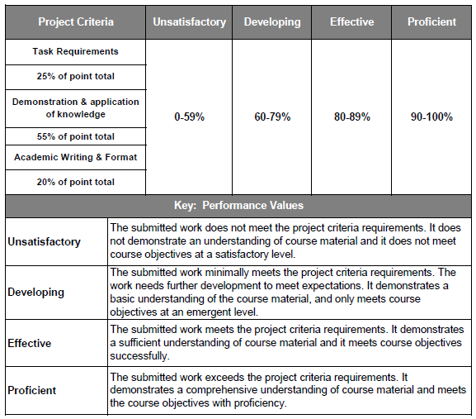
You have just been hired as the vice president of advertising and public relations. The president of the company has sent you the following message to give you an idea of what the company is about and what is expected from you in your new role:
Introduction
Welcome to the first of our strategic planning meetings. Before we get started, I would like to thank you for joining our bank in the capacity of Vice President, Advertising and Public Relations. Although we only have five branches located throughout our state and are considered a small bank by some, we not only wish to grow, but must grow or we will be swallowed by the big banks that are operating all around us. We have been too stagnant for too long and it is time to move forward. Senior management conducted several strategy sessions, and it was decided that we needed a new approach, which is why we created this new position and brought you on board to lead the charge.
We have never had a strong focus on public relations as a marketing tool, and we have also never really considered advertising as a requirement because we have relied mostly on referrals and word-of-mouth advertising in the past. This has served us well as a local bank, but based on increasing competition and the need for additional revenue, we need to grow beyond our existing customer base. This is where you come in.
I realize you have a very strong marketing background in advertising and public relations and have helped several organizations meet many of the same objectives that we are trying to achieve. By using someone from outside of the bank, we hope to bring in creative and fresh approaches to our strategic initiative. Ultimately, you are responsible for goal achievement. Let’s discuss the situation.
Background and Present Customer Base
As you are aware, we have been around for 30 years and have grown to 5 branches throughout the state. Our customers love us because we treat them like real people, focus on strong customer service, and give every customer the attention they require. We offer basic banking services from our 5 physical locations. Our services include savings accounts, checking accounts, CD’s, and loans.
We love our present customer base and do not want to lose them because they made us what we are today; however, our current local customers create very high expenses and offer little current or future revenue growth opportunities. They have very little money in their checking and savings accounts, so as a bank, we make very little on those assets. In addition, they carry a high cost per customer, which reduces our profit. They tend to be people from older generations who are not technologically savvy, require constant attention from our branch representatives through face-to-face transaction processing, insist on receiving paper bank statements, and refuse to use our ATMs. In addition, these customers are not the type that are taking out big loans and mortgages, which is really where we make a lot of money on the interest. Basically, we love our customers and want to keep them, but they cost us a lot of money and provide a very low return on investment (ROI). We need to penetrate a new market segment, and unfortunately, I do not know who that is.
Our current marketing strategy is to use our present customers to help us find new customers, but so far, we have not grown outside of our present, mostly unprofitable, market segment.
Next, as we have discussed, we currently offer no online banking or e-commerce services. That is rapidly changing because we are already working on the entire technical infrastructure. That will be ready to go soon, but we need to know how to get the word out regarding that initiative to the right new target market. In the marketing world, you call that reach and frequency.
Although this is a marketing-focused endeavor, you must create a strategic marketing plan before launching. This plan will set the bank’s marketing direction and bring the bank’s strategic goals down to an operational level where you can move forward based upon board approval of your plan and recommendations.
Reasons for Change
Based on the information above, we need to change the way that we do business to remain competitive; otherwise, the big banks will wipe us out. Specific reasons for the change include the following:
- Competition
  - We have no competitive advantage
    - The competition is growing, even in our own local geography, and starting to erode our current customer base.
- ROI is minimal based on the current customer base
- Expenses are high based on current customer base
- Limited growth potential in the current customer base
- Public relations is a key channel offering many opportunities
- Embrace advertising to expand beyond our customer base
- Advertising and public relations will be required to announce and successfully achieve the goals for our new branding and direction
The Bank’s Long-term Strategic Goals
- Increase overall profit and ROI
- Create a competitive advantage through our e-commerce initiative
- Identify and penetrate a profitable new market segment
- Use effective advertising and public relations to drive all 3
General Direction Forward
Achieving our long-term strategic goals should be based on the following overall components:
- We must find and establish our presence within a new profitable target segment. This encompasses launching new products and services, including the establishment of a very strong e-banking program that is based on the specific requirements of the new target market.
- We must develop an integrated advertising program that is inclusive of a strong public relations component. The focus of both the advertising and public relations will be penetrating our new segment through effective advertising and public relations, eventually resulting in increased profit.
An Overview of Your Role Moving Forward
The steps that will need to be taken to complete this initiative are as follows:
- Phase 1: Create advertising and public relations objectives that align to each of the 4 strategic goals. These represent the goals that you will achieve through the team’s efforts.
- Phase 2: Identify a new target market, and create service and product offerings that are tailored to that segment by utilizing the marketing mix. You will also investigate appropriate communication channels to reach this market.
- Phase 3: Create your branding strategy (position statement) for your new target market based on your situation analysis. This will start to integrate your goals, your situation analysis results, and your target market. This includes understanding, anticipating, and integrating plan components based on the potential impact of external influences (regulatory, economic, social, technology, etc.) that affect marketing.
- Phase 4: Create a public relations piece that you will use that is based on the target market needs, and include specific measures to gauge if it is effective. This will include tracking from an ROI perspective. You will present a preliminary proposal to senior management in advance of the final presentation to the full board in Phase 5.
- Phase 5: Give a final presentation to the bank president and the board with your overall recommendations. This will include how the strategy is integrated between the four components of the marketing mix.

